Group no : 30

Homework 4 - Software Engineering

Member list:

|  |  |
| --- | --- |
| **Name** | **Email ID** |
| Surabhi Ravindran Nair | snair3@ncsu.edu |
| Sreeja Nukarapu | snukara@ncsu.edu |
| Aarthi Hasitha Yepuri | ayepuri@ncsu.edu |

Repository URL - https://github.com/Fall-2024-SE-Group/HW4

Screenshot:

Task1.sh



Task2.sh

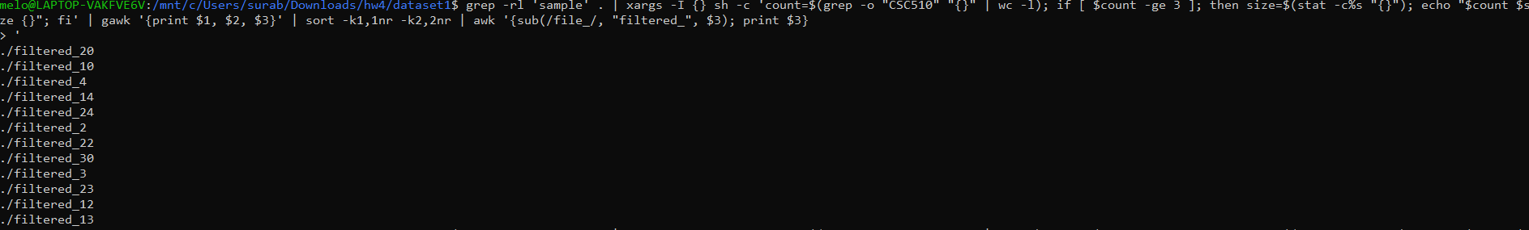

Task3.sh